K L UNIVERSITY
FRESHMAN ENGINEERING DEPARTMENT

A Project Based Lab Report On
ERP-BASED STUDENT COURSE REGISTRATION SYSTEM

SUBMITTED BY:
ID NUMBER NAME
2500032154 Aman Raj
2500032275 Rishith Choudhary
2500032289 Dumpala Hasini
2500032151 Venkata Manikanta

UNDER THE ESTEEMED GUIDANCE OF Dr. N. Sreeram
ASSISTANT PROFESSOR



KL UNIVERSITY
Green fields, Vaddeswaram – 522 502 Guntur Dt., AP, India.

DEPARTMENT OF BASIC ENGINEERING SCIENCES



CERTIFICATE

This is to certify that the project based laboratory report entitled “ERP – BASED STUDENT COURSE REGISTRATION SYSTEM” submitted by Aman Raj,Rishith Chowdhary, Dumpala Hasini, Venkata Maninkanta bearing Regd. No. 2500032154, 2500032275, 2500032289, 2500032151 to the Department of COMPUTER SICENCE ENGINEERING , KL University in partial fulfillment of the requirements for the completion of a project based Laboratory in “PYTHON PROGRAMMING (25SC2007)” course in I B Tech II Semester, is a Bonafede record of the work carried out by him/her under my supervision during the academic year 2025 – 2026.

PROJECT SUPERVISOR HEAD OF THE DEPARTMENT Dr. N. Sreeram Dr. D. HARITHA

ACKNOWLEDGEMENTS

It is great pleasure for me to express my gratitude to our honorable President.

Sri. Koneru Satyanarayana, for giving the opportunity and platform with facilities in accomplishing the project-based laboratory report.
I express sincere gratitude to our Director Dr. A. Jagdeesh for his administration towards our academic growth.
I express sincere gratitude to our Coordinator and HOD-BES Dr. D. Haritha for her leadership and constant motivation provided in successful completion of our academic semester. I record it as my privilege to deeply thank you for providing us with the efficient faculty and facilities to make our ideas into reality.
I express my sincere thanks to our project supervisor Dr. N Sreeram for her novel association of ideas, encouragement, appreciation, and intellectual zeal which motivated us to venture this project successfully.
Finally, we are pleased to acknowledge our indebtedness to all those who devoted themselves directly or indirectly to making this project a success.

Name: Aman Raj
Rishith Chowdhary
Dumpala Hasini
Venkata Manikanta

ID No: 2500032154
2500032275
2500032289
2500032151

ABSTRACT

The Student Course Registration System is a simple ERP-based application developed using Python that operates through a terminal interface. The main objective of this system is to manage student course registrations efficiently by providing basic functionalities such as adding, viewing, searching, and deleting student records.
This system allows users to register students along with their selected courses and store the data in a structured format during program execution. It uses fundamental programming concepts like lists, dictionaries, functions, and loops to simulate real-world ERP operations in a simplified manner.

The application is menu-driven, making it user-friendly and easy to navigate. It helps reduce manual errors and provides quick access to student information. Although it is a basic implementation without a database, it demonstrates the core idea of how ERP systems manage academic data.

This project is suitable for beginners and serves as a foundation for developing more advanced systems with features like database integration, authentication, and graphical user interfaces.

INDEX

S.NO | TITLE | PAGE NO
1 | Introduction | 6
2 | Aim of the Project | 7
2.1 | Advantages & Disadvantages | 8
2.2 | Future Implementation | 8
3 | Software & Hardware Details | 9
4 | Data Flow Diagram | 10-11
5 | Algorithm for each module | 12
6 | Implementation | 13-15
7 | Integration and System Testing | 16-18
8 | Conclusion | 19

INTRODUCTION
In today’s digital era, educational institutions are increasingly adopting automated systems to manage academic activities efficiently. One of the essential components of such systems is course registration, where students enroll in subjects for a particular term. Performing this process manually can be time-consuming, error-prone, and difficult to manage, especially when dealing with a large number of students.

The Student Course Registration System is a basic Enterprise Resource Planning (ERP)-based application developed using Python. This system is designed to simplify and streamline the process of registering students and assigning courses through a terminal-based interface. It provides essential functionalities such as adding new student records, viewing registered students, searching for specific students, and deleting records when needed.
The project demonstrates how core programming concepts like data structures, functions, and control statements can be used to build a simple yet effective management system. Although it does not use a database or graphical interface, it gives a clear understanding of how real-world ERP systems function at a fundamental level.

This system serves as a beginner-friendly model for learning application development and can be further enhanced by integrating advanced features such as data persistence, user authentication, and graphical user interfaces.

AIM

The aim of this project is to develop a simple ERP-based Student Course Registration System using Python that allows users to efficiently manage student course data through a terminal interface. The system is designed to perform basic operations such as registering students, viewing records, searching for specific students, and deleting student details.
It also aims to demonstrate the use of fundamental programming concepts like lists, dictionaries, functions, and control structures in building a real-world application. Additionally, the project serves as a foundation for understanding how ERP systems work and how they can be expanded with advanced features like database integration and user authentication.

ADVANTAGES
- Simple and easy to use terminal-based interface
- Reduces manual work in managing student records
- Fast access to student and course information
- Easy to implement using basic Python concepts
- Helps in understanding ERP system fundamentals
- Requires very low system resources

DISADVANTAGES
• Data is not stored permanently (lost after program ends)
• No graphical user interface (GUI)
• Limited functionality compared to real ERP systems
• No user authentication or security features
• Cannot handle large-scale data efficiently
• Single-user system (no multi-user support)

FUTURE IMPLEMENTATION
- Add database integration (MySQL / SQLite) for permanent storage
- Develop a graphical user interface (GUI) using Tkinter or PyQt
- Implement login system (Admin & Student roles)
- Allow multiple courses per student
- Add features like attendance, marks, and GPA calculation
- Introduce course capacity limits and validation
- Convert into a web-based ERP system using Flask or Django
- Enable multi-user access and cloud storage

SYSTEM REQUIREMENTS

SOFTWARE REQUIREMENTS:
The major software requirements of the project are as follows: Language: Python.
Operating system: Windows 10 or more.
Technical requirements: Monitor, CPU, Keyboard, Mouse, etc...

HARDWARE REQUIREMENTS:
The hardware requirements that map towards the software are as follows: RAM: 8 GB.
Processor: i5/i7.

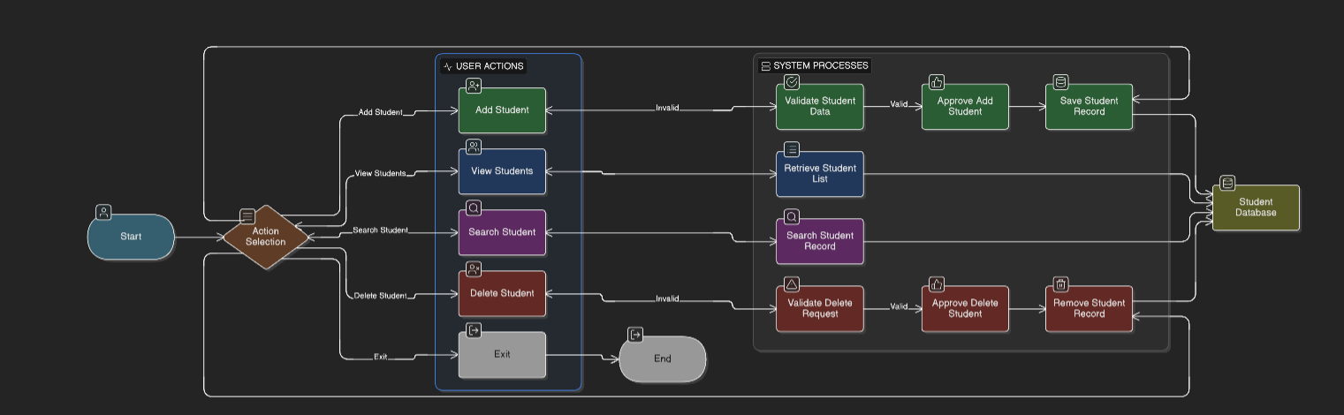
DATA FLOW DIAGRAM

book
ticket.
Read selection.
print insert movie.
print find movie.
view all.
Display

ALGORITHM
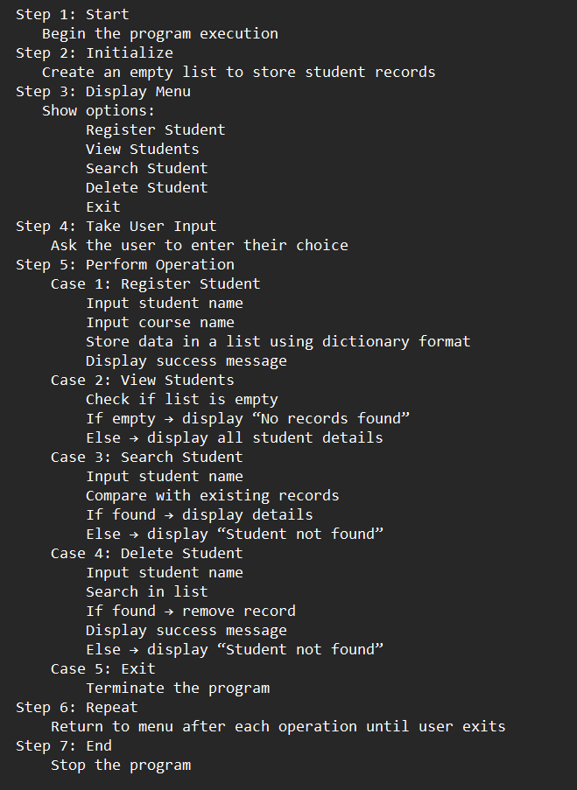

IMPLEMENTATION

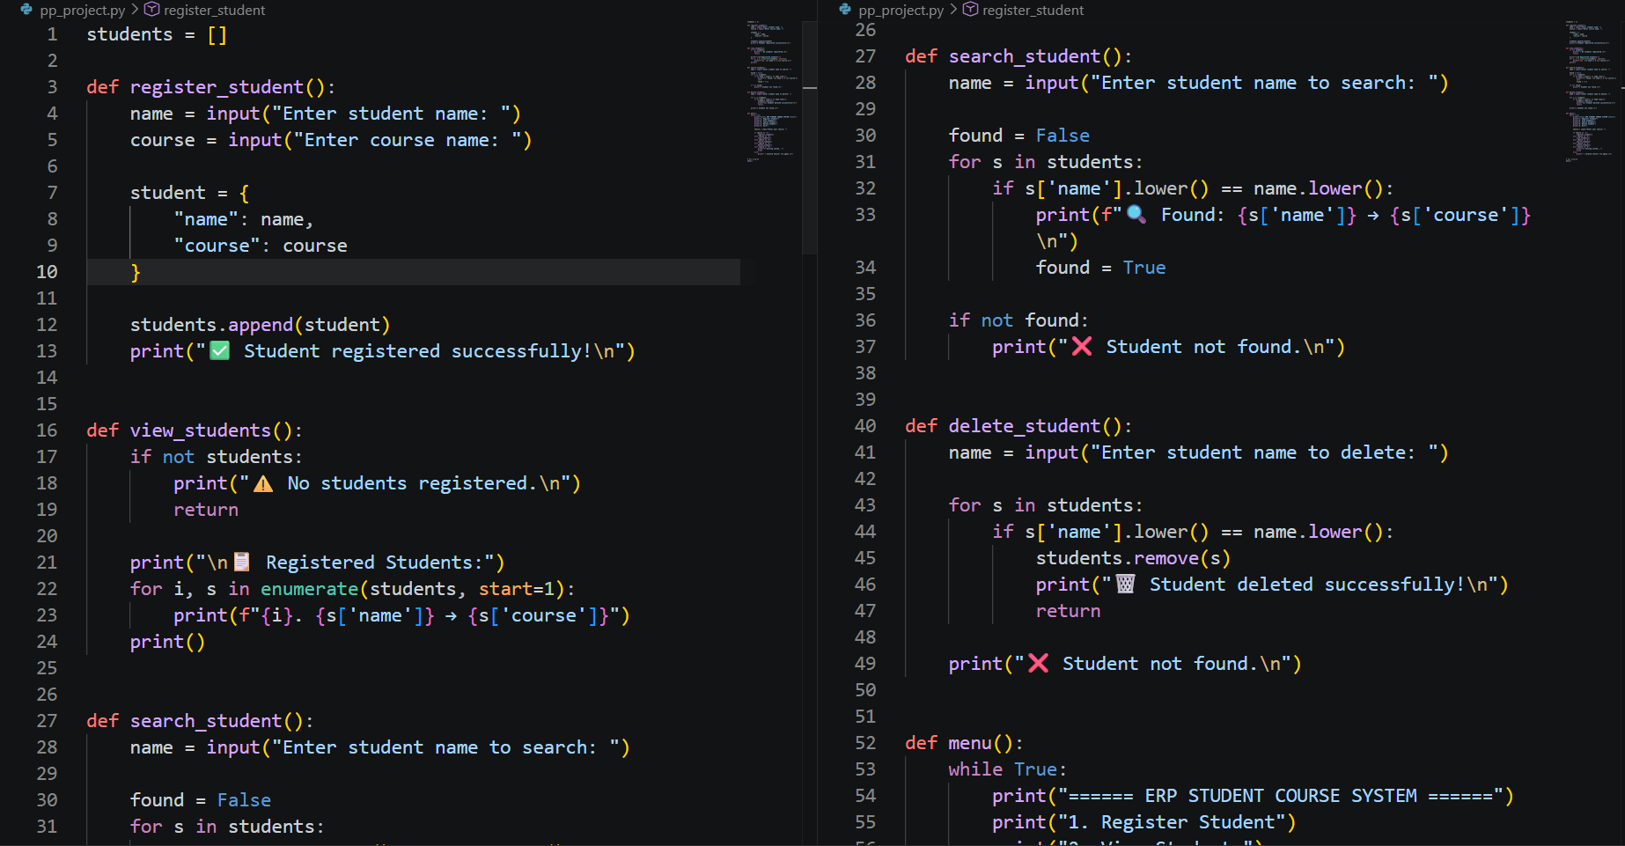

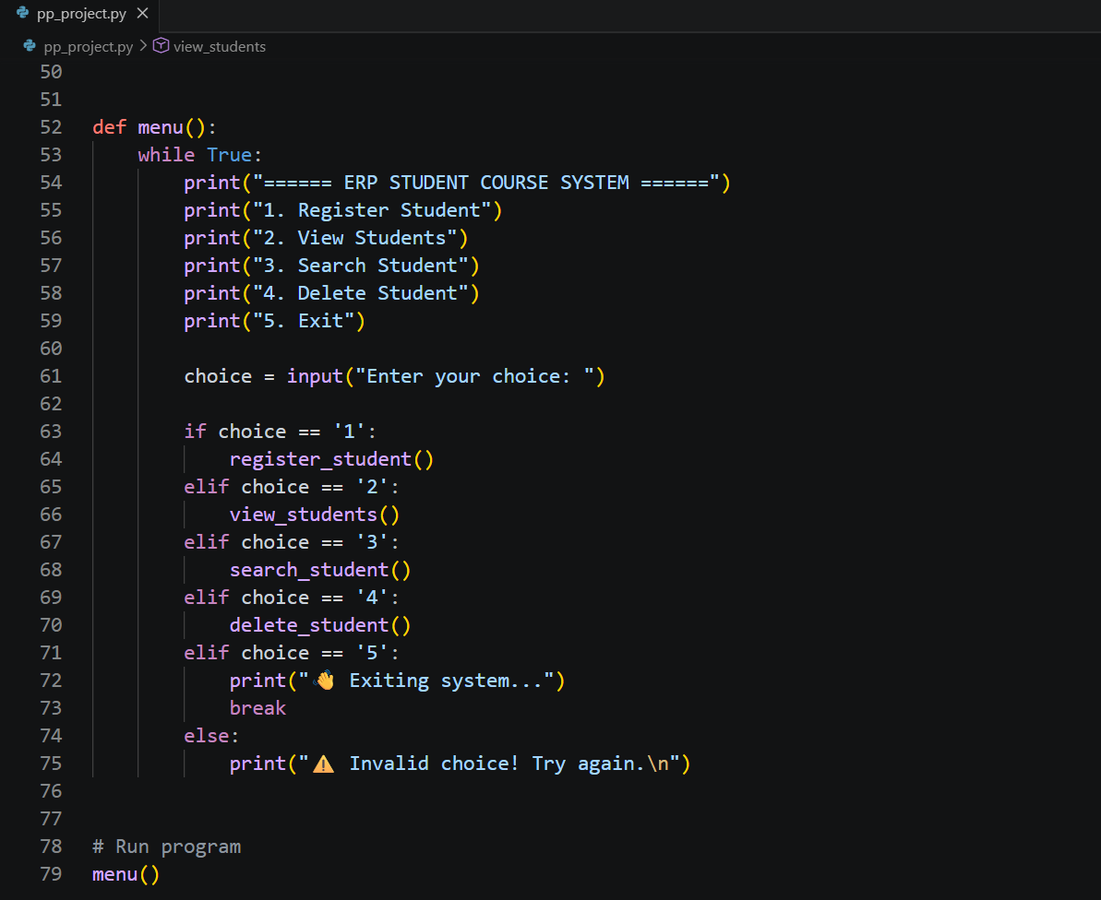

INTEGRATION AND SYSTEM TESTING
OUTPUTS

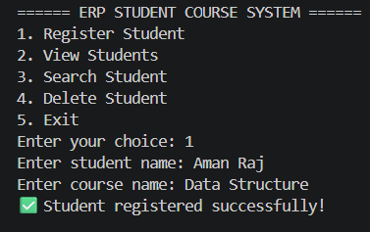
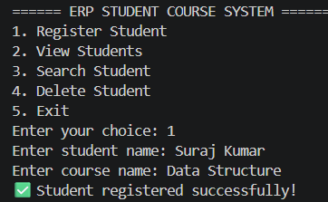
Screen Shots:
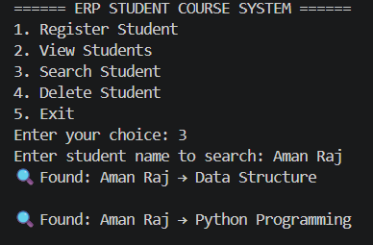
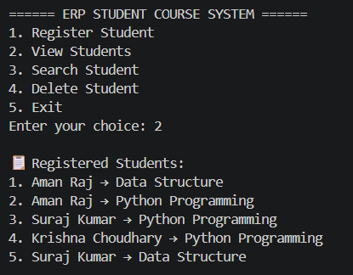
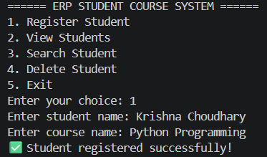
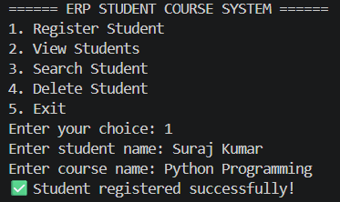
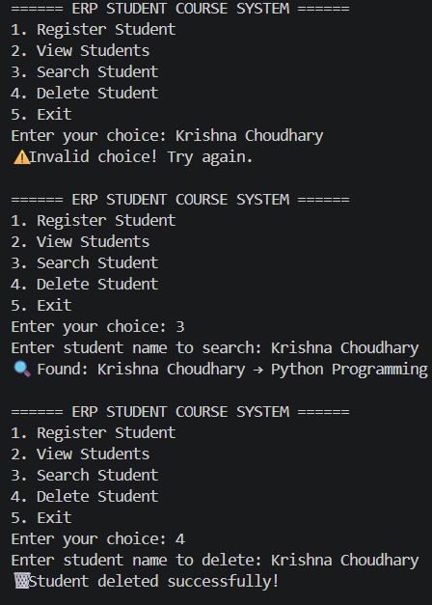

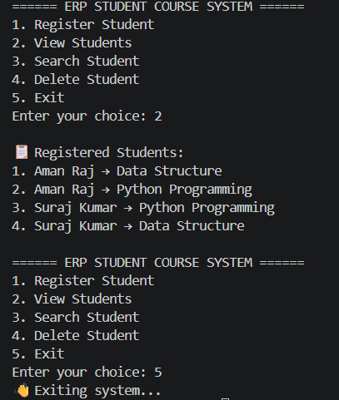

CONCLUSION
The Student Course Registration System developed using Python successfully demonstrates a basic ERP concept through a simple terminal-based application. The system is able to perform essential operations such as registering students, viewing records, searching for specific entries, and deleting data efficiently.
This project highlights the practical use of fundamental programming concepts like data structures, functions, and control flow in solving real-world problems. It reduces manual effort and provides a structured way to manage student course information.
Although the system is limited in features and does not include advanced functionalities like database storage or a graphical interface, it serves as a strong foundation for understanding how ERP systems work. With further enhancements such as database integration, user authentication, and a GUI, the system can be expanded into a more powerful and scalable application.
Overall, the project provides valuable learning experience and a clear understanding of building basic management systems using Python.

19

